ASSINGMENT – 03

Creating table 1

create table departments(dept_id number,dept_name varchar(30));



Inserting values

insert into departments values(1,'IT');

insert into departments values(2,'HR');

insert into departments values(3,'Finance');

insert into departments values(4,'Marketing');

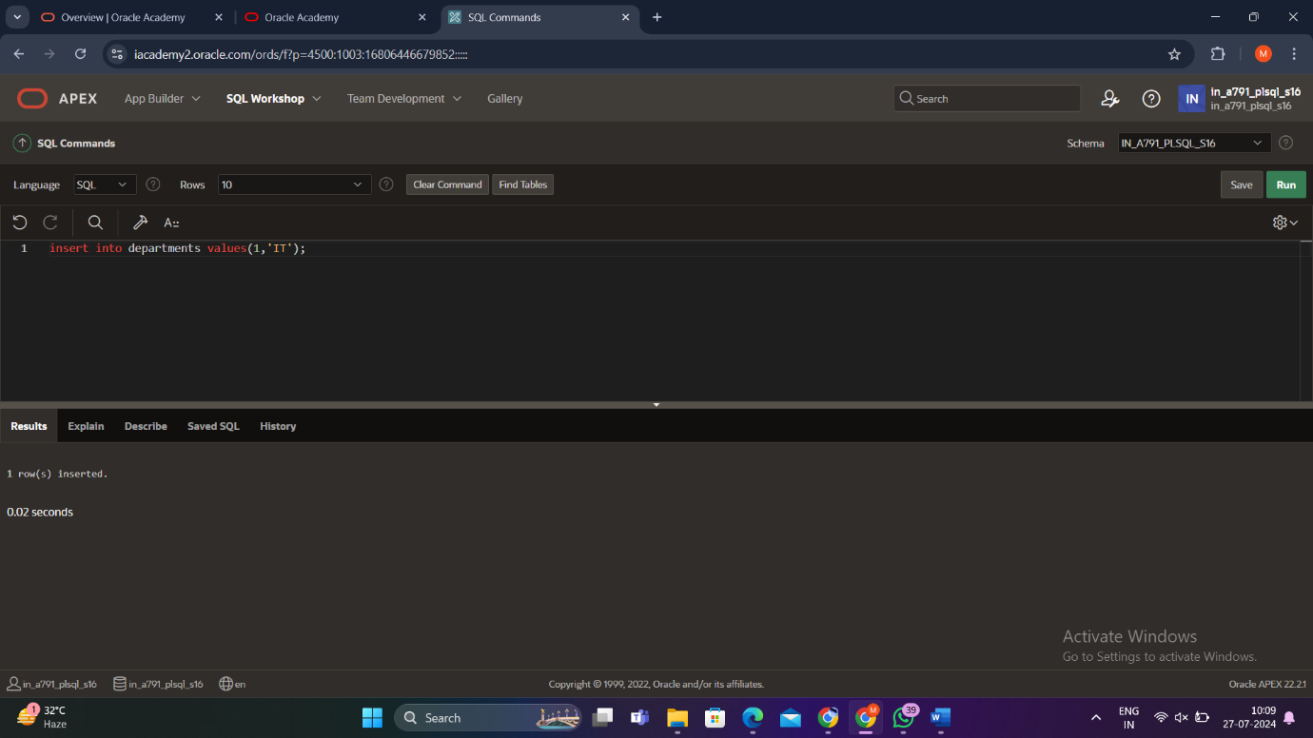

Creating table 2

create table employees(emp_id number,emp_name varchar(30),dept_id number,salary decimal(10,2));

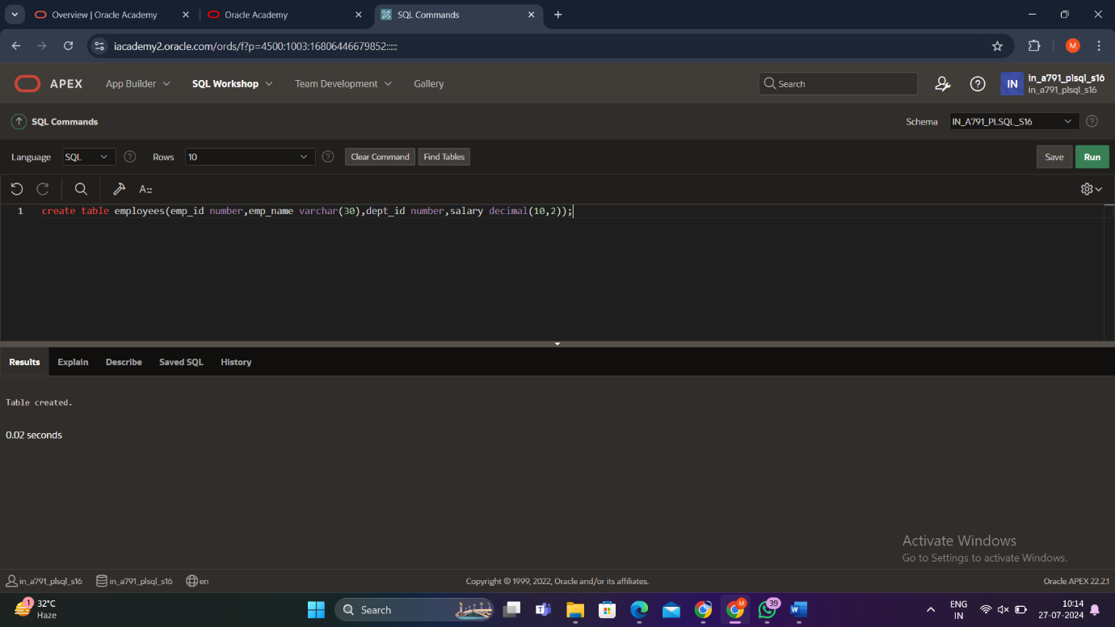

Inserting values

insert into employees values(1,'aaa',1,50000.00);

insert into employees values(2,'bbb',1,55000.00);

insert into employees values(3,'ccc',2,60000.00);

insert into employees values(4,'ddd',2,58000.00);

insert into employees values(5,'eee',3,62000.00);

insert into employees values(6,'fff',3,61000.00);



Finding average salary

SELECT

d.Dept_ID,

d.Dept_name,

(SELECT AVG(e.Salary)

FROM Employees e

WHERE e.Dept_ID = d.Dept_ID

) AS AvgSalary

FROM Departments d

ORDER BY AvgSalary DESC;

